

UNITEDWORLD SCHOOL OF COMPUTATIONAL INTELLIGENCE (USCI)

Summative Assessment (SA)

Submitted BY

Shaily Antala

(Enrl. No.: 20220701037)

**Course Code and Title: 21BSCS23C07 – R Programming (Deepti Ameta)**

B.Sc. (Hons.) Computer Science / Data Science / AIML

III Semester – July – Nov 2023



Nov/Dec 2023

**REPORT ON MEDICAL RECORDS**

**INDEX**

|  |  |  |
| --- | --- | --- |
| **SR. NO.** | **TITLE** | **PAGE NO.** |
| **1** | **Introduction** | **2** |
| **2** | **Aim of the project** | **2** |
| **3** | **Intended outcome of the project** | **2-3** |
| **4** | **Dataset** | **3-9** |
| **5** | **Data description** | **9-11** |
| **6** | **Proposed methods** | **11** |
| **7** | **Statistical analysis** | **11-14** |
| **8** | **Statistical visualization** | **14-21** |
| **9** | **Deep learning algorithms** | **21-22** |

**INTRODUCTION**

Medical Analytics in the realm of Healthcare plays a vital role in understanding the intricacies of the patient well-being as well as the efficiency of the healthcare systems. By taking various attributes to consider for the analysis the sector can proliferate. In this comprehensive we look at diverse patient profiles, each representing some unique set of medical conditions and included treatment plans.

A well-organized medical health report is an essential tool for healthcare providers, offering a path for efficient coordination and communication between the different medical specialists involved in a patient's care. It documents the patient's whole medical experience and is an invaluable tool for analysis and future reference.

**AIM OF THE PROJECT**

It aims to gather insights regarding varying patterns and respective trends, correlations within the dataset, resources utilized, with an overall intervention of results.

Utilizing cutting-edge statistical and data analysis methods to extract valuable insights from patient health data is the main goal of creating a medical health report in R. R is an effective statistical computer language that helps medical practitioners easily organize, analyze, and visualize a variety of medical data.

**INTENDED OUTCOME OF THE PROJECT**

The medical health report intends the following outcomes :

* Understanding the incidence of a disease by observing its contributing demographic factors.
* Assessing medical treatments and intervention of patient to identify factors influencing recovery.
* Evaluation of cost to improve with cost-effectiveness as a healthcare strategy.
* Data driven decision making.
* Predictive model to analyze progression, and complications.

**DATASET**

**CODE**



**DATA-LOADED**

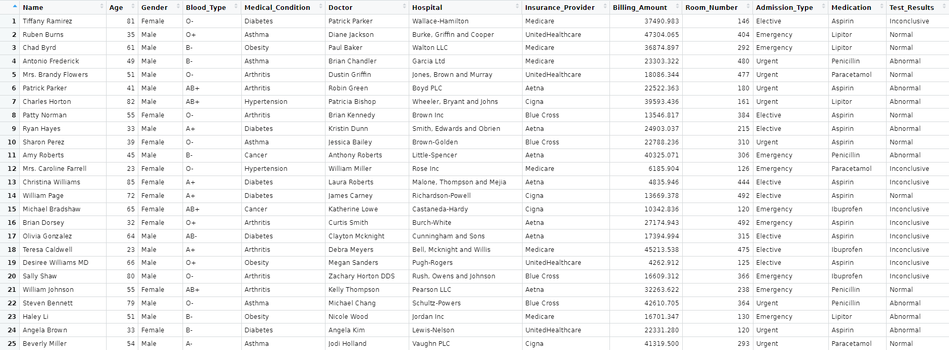

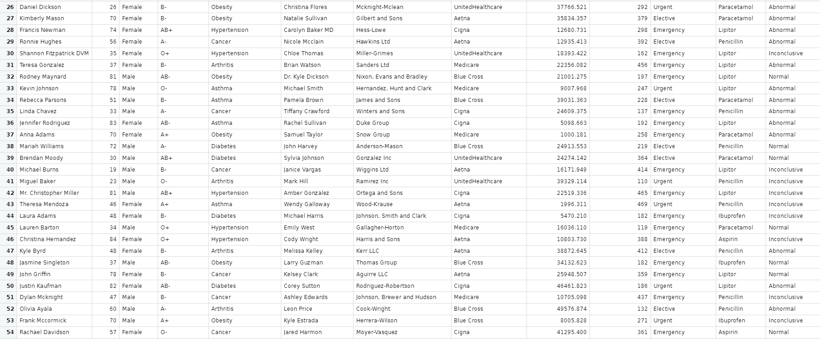

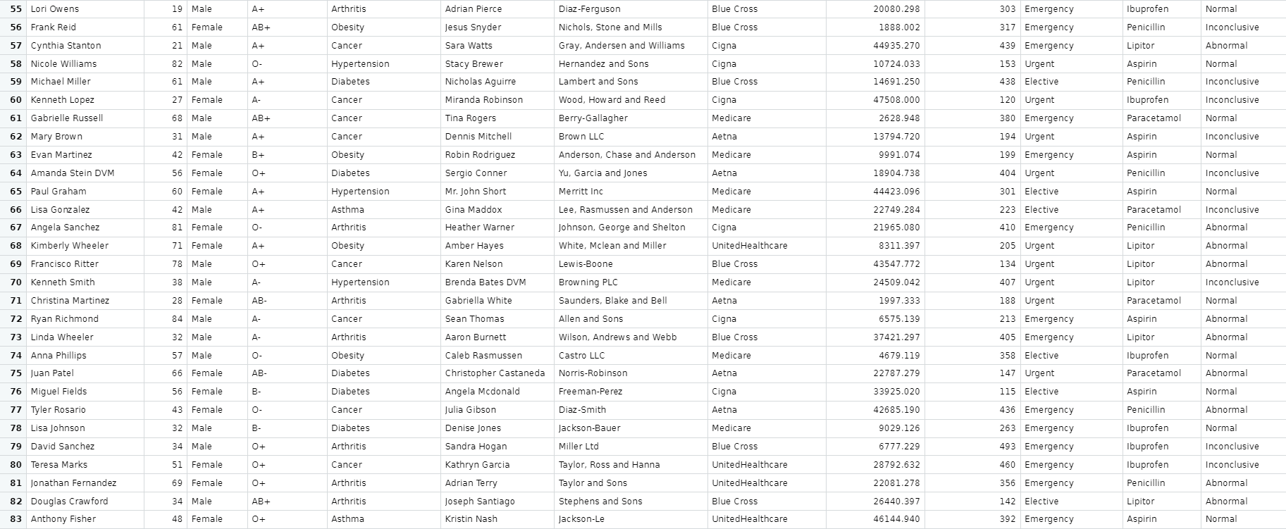

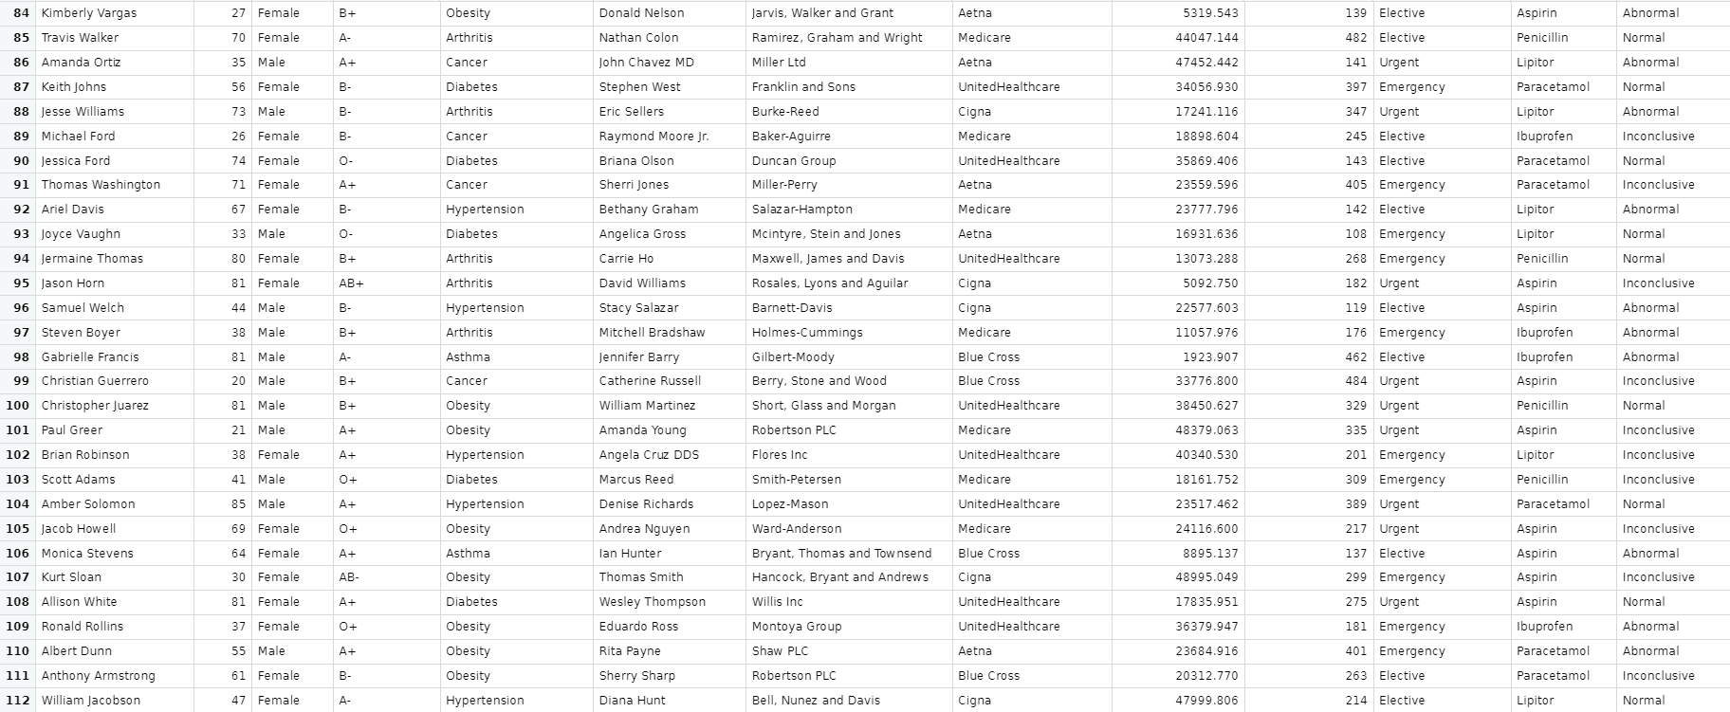

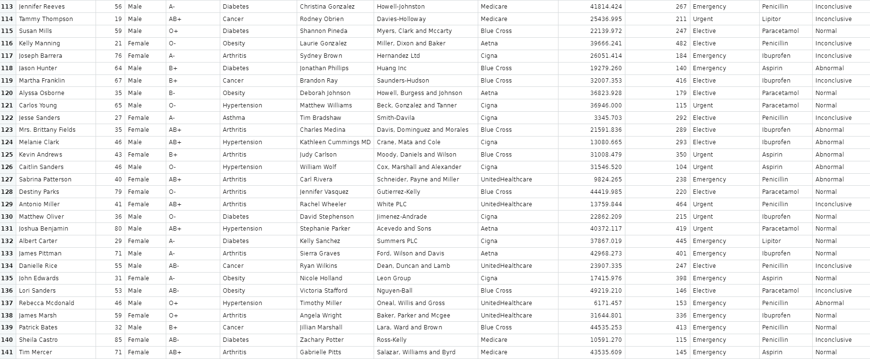

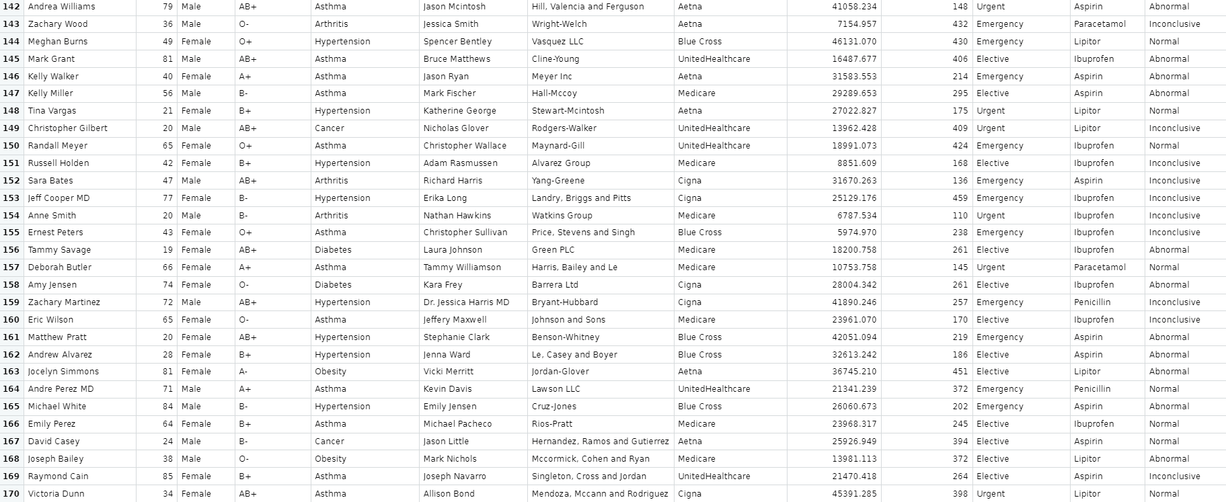

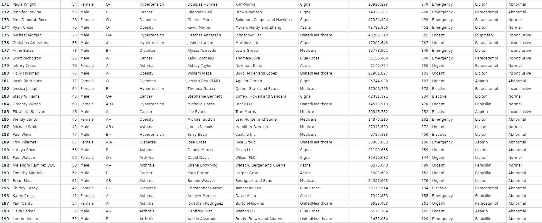

**DATASET DESCRIPTION**

The dataset consists of the following key attributes:

Name: patients name

Age: patients age

Gender: patients gender

Blood type: patients blood type

Medical condition: the medical condition for which the patient is being treated

Doctor: the doctor assigned to the respective patient

Hospital: the hospital where the patient is admitted

Insurance provider: the patients insurance provider

Billing amount: the total billing amount for the treatment

Room number: the room number where the patient will be staying

Admission type: the type of admission (elective, emergency, urgent)

Medication: the medication prescribed to the patient

Test results: the results of the medical treatments conducted

As the dataset showcases the occurrence of some common medical conditions it becomes essential to have a basic understanding of these.

The different conditions includes diabetes, asthma, obesity, hypertension, cancer and arthritis.

1. Diabetes:

It is a chronic condition caused due to elevated blood sugar levels. Researchers found studies that talks on various management strategies such as proper medication, lifestyle modifications, role of healthcare providers. Various other sources tell the impact of diabetes based on different age groups.

1. Asthma:

It is a respiratory based condition which affects a person’s airways causing breathing issues and related difficulties. The most preferred treatments for emergency interventions, as per the latest advancements is the use of inhalers (e.g. Lipitor). This conditions degree of affecting a person can be influenced by age, gender and even blood type.

1. Obesity:

It is seen as a general cause affecting every 5 people out of 8 at most. This condition is associated with health risks including hypertension and diabetes. Researches also conclude the role of genes might be significant in causing it but its cure and treatments involves the basic or regular prescribed medication to control and prevent the situation from getting out of hands.

1. Hypertension:

This can also be classified as one of the most common form of condition among all age groups. It is characterized as a result of high blood pressure. It has a correlation with diabetes and obesity. Treatments focuses on medications but majorly on lifestyle improvements that involves getting the patients mental health fit and to make their daily tasks get done, stress and tension free manner.

1. Cancer:

It is a very serious condition if chronic, but even a slightest hint of cancerous cells can be a fatal sign. It is a disease cased due to uncontrolled cell growth. This may cause a person to lose their hair. Many treatments involving medications like penicillin alongside of chemotherapy seems to get better outcomes. Researches show emerging new therapy forms and personalized medicine for cancer patients.

1. Arthritis:

This condition results in inflammation of the joints. Various advancements in treatments include medications such as lbuprofen and paracetamol. Such a condition might be seen more among the older age group.

Some more insights on what the dataset includes:

* Research in healthcare economics and policy may cover the role of insurance providers and billing practitioners in the systems , such as Medicare or UnitedHealthcare.
* Topics like healthcare accessibility, disparities, as well as impact of insurance coverage on the patient outcomes are also highlighted.
* Admission types (elective, urgent, emergency) along with medication effectiveness and safety profiles are likely presented.
* The importance of accurate and timely test interpretations.
* It also showcases various distributions on the bases of age, gender and blood type.

**PROPOSED METHODS**

PLANNING OF THE TREATMENT:

Recommendation of particular medications, surgeries or therapies.

LIFESTYLE CHANGES:

Modification in a patients daily routine gets essential in preventing health issues.

MEDICATION MANAGEMENT:

Proper guidance with highlighting any potential drug to be included as a strict follow up.

Showcasing the importance of adherence to a prescribed medication.

PROPER MONITORIZATION:

Proper monitoring of a patient and ensuring the follow-up appointments.

24/7 watch on critical patients and emergency management.

EMERGENCY RESPONSE PLANNING:

Provide with a set of instructions always on ethical and legal matters during an emergency call for duty.

**STATISTICAL ANALYSIS**

**INPUT :**

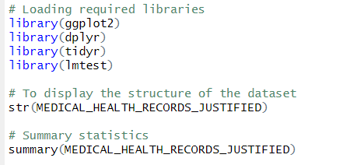

**OUTPUT:**

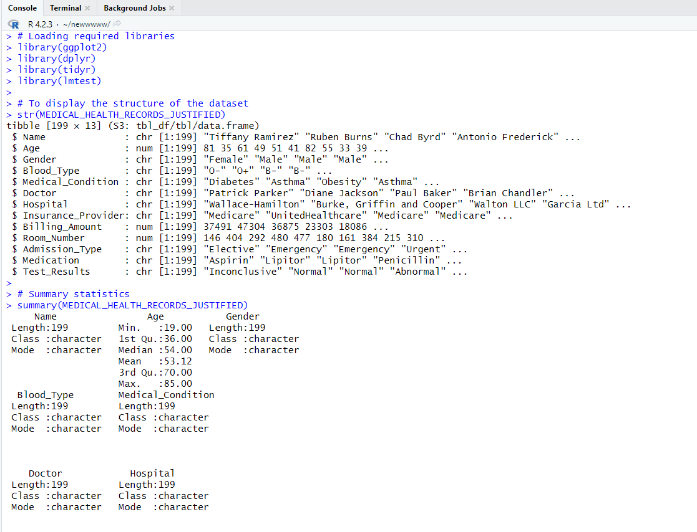

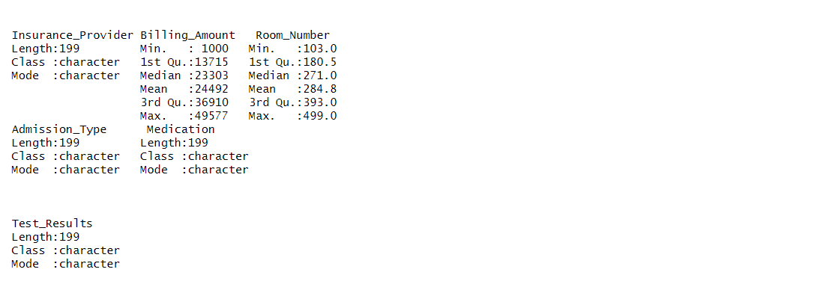

**INPUT :**



**OUTPUT:**

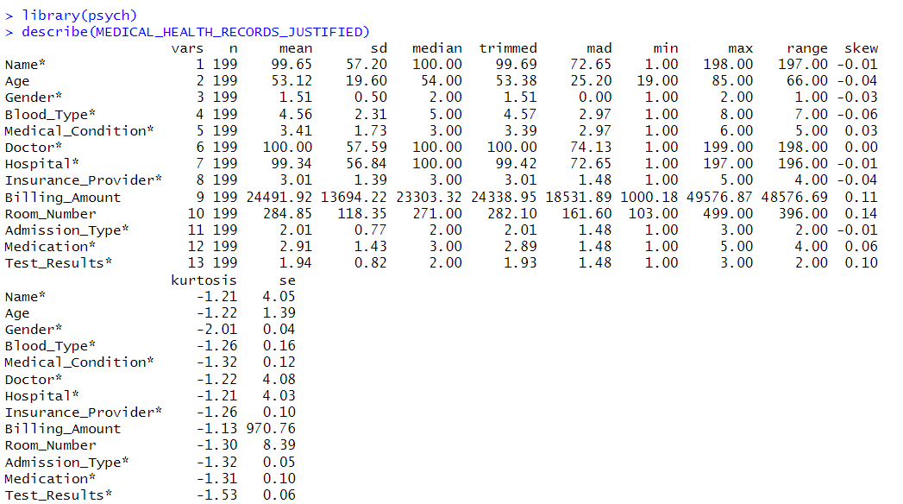

**INPUT:**

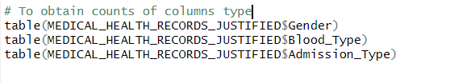



**OUTPUT:**

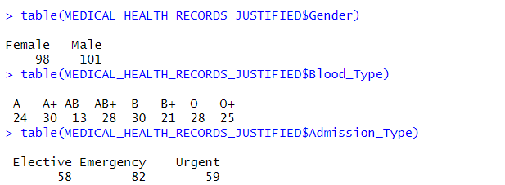

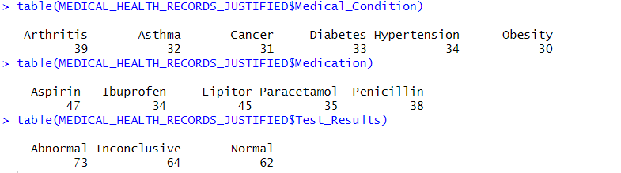

**STATISTICAL VISUALISATION**

**INPUT:**

plot(MEDICAL_HEALTH_RECORDS_JUSTIFIED)

**OUTPUT:**

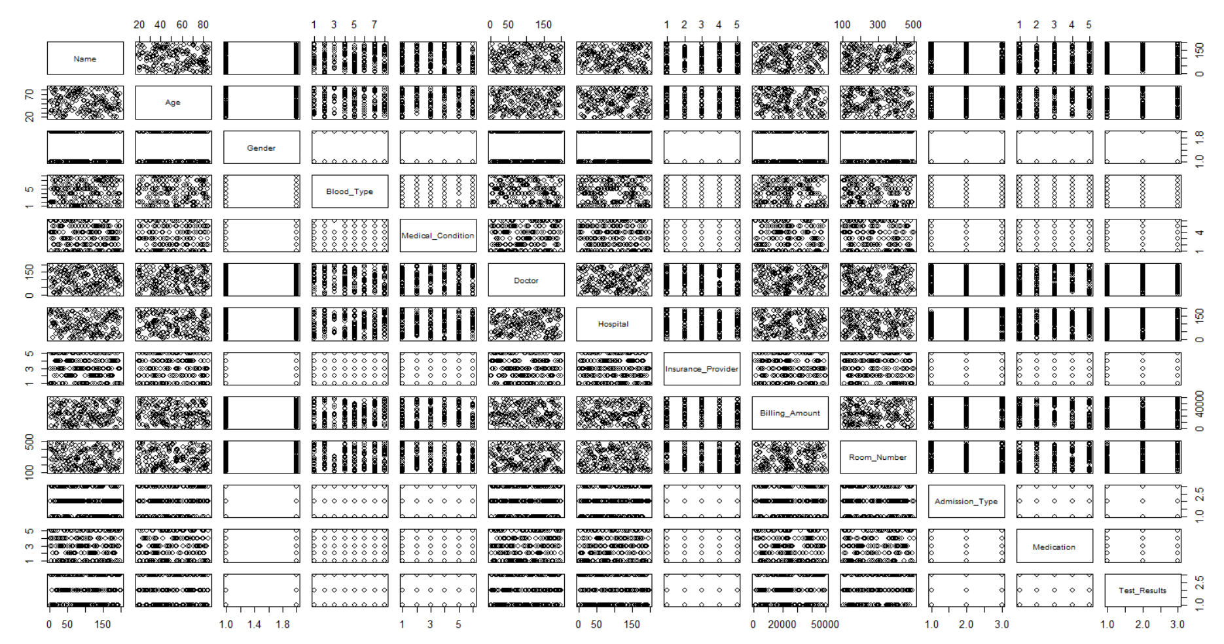

**INPUT:**

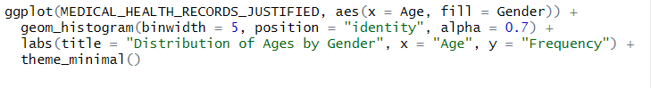

**OUTPUT:**

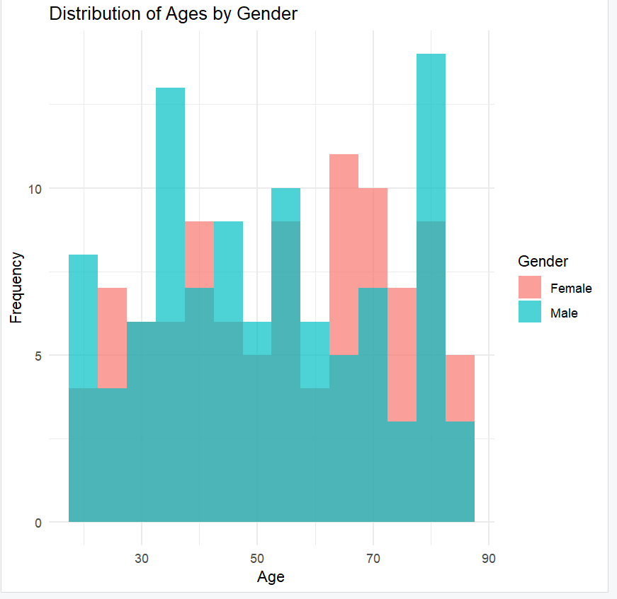

**INPUT:**

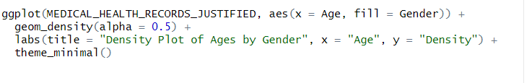

**OUTPUT:**

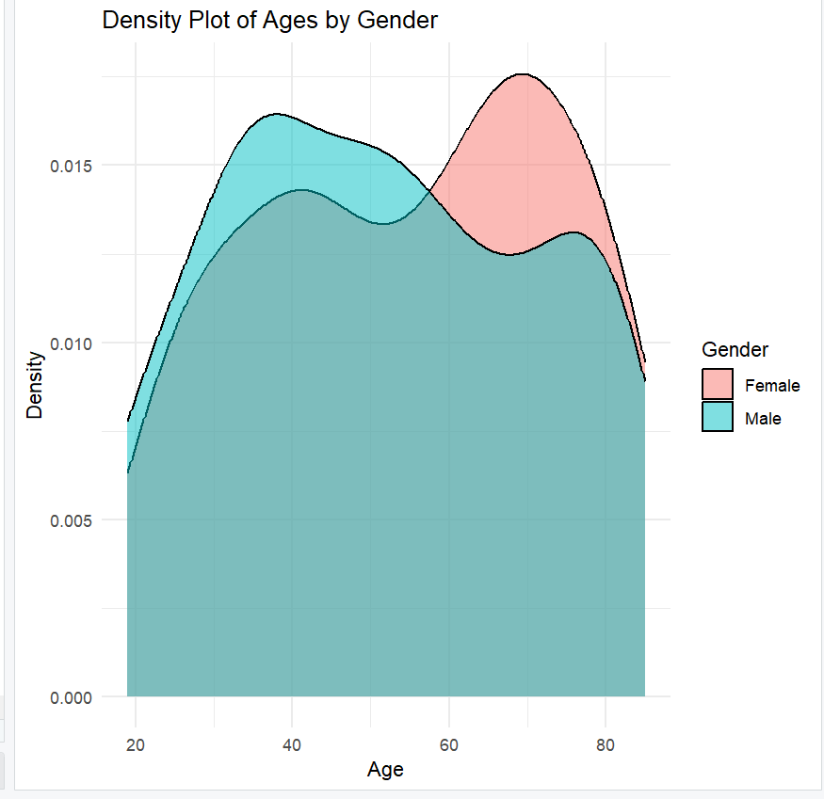

**INPUT:**



**OUTPUT:**

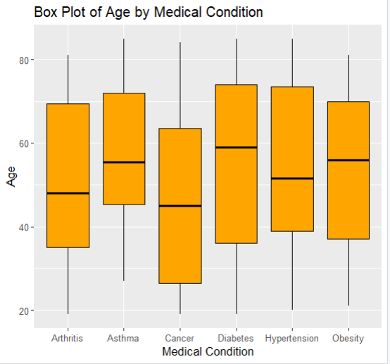

**INPUT:**



**OUTPUT:**

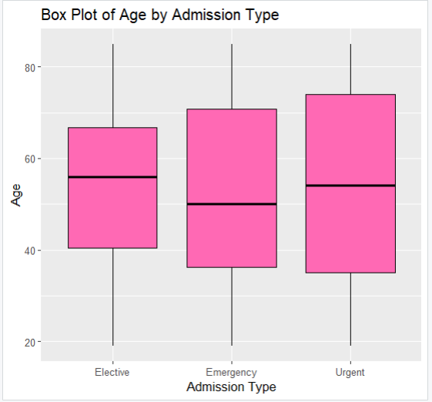

**INPUT:**

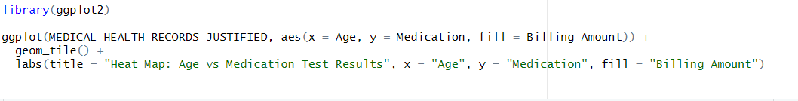

**OUTPUT:**

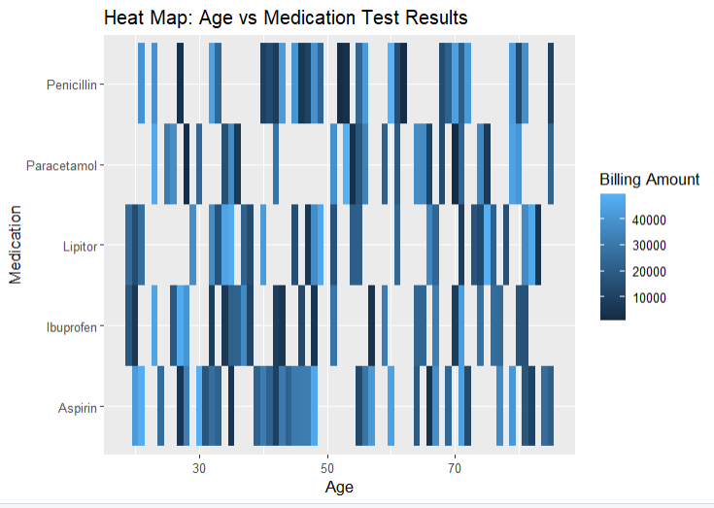

**INPUT:**

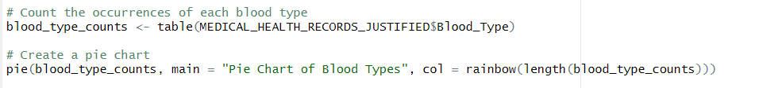

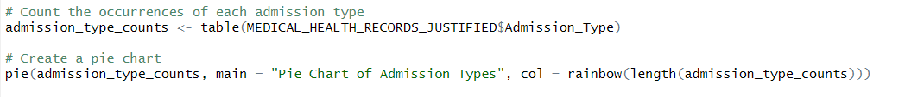

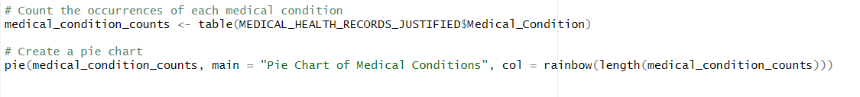

**OUTPUT:**

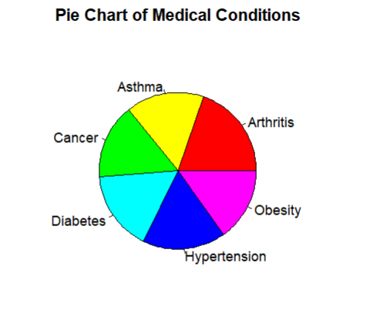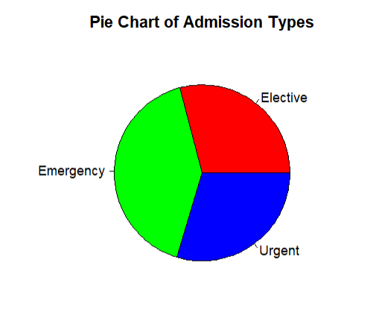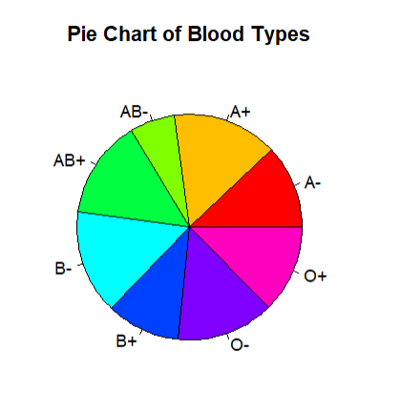

**INPUT:**

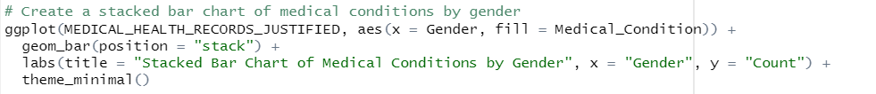

**OUTPUT:**

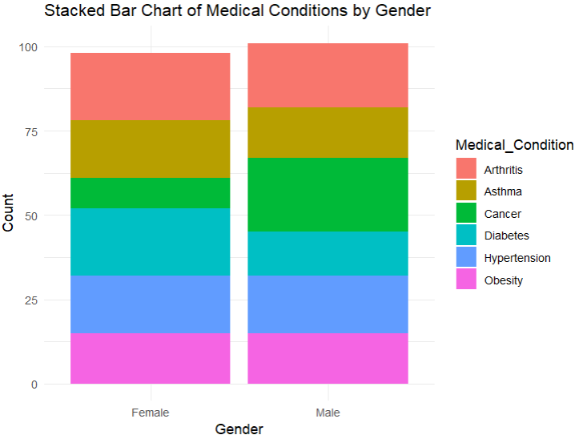

**MACHINE LEARNING AND DEEP LEARNING ALGORITHMS**

VARIOUS ALGORITHMS FOR DIFFERENT TASKS:

CLASSIFICATION TASKS:

Disease predicting algorithms such as Logistic Regression, Random Forest, Support Vector Machines (SVM), Neural Networks.

Risk Stratification such as Decision Tree, Gradient Boosting, Neural Networks.

REGRESSION TASKS:

Using bill predicting algorithms such as Linear Regression, Random Forest Regressor, Gradient Boosting, Long Short-term memory network(LSTM).

CLUSTERING TASKS:

Using K-means or hierarchical clustering for patient segmentation.

TREATMENT RECOMMENDATION TASKS:

Implementing the use of pre-trained models that follow a path to provide correct prescriptions necessary.

DETECTING ANOMALY:

Isolation Forest or One – Class SVM or Autoencoders to detect any unusual medical conditions.

MONITORING PATIENT HEALTH:

LSTM, Autoregressive Integrated Moving Average (ARIMA) to better the monitoring.